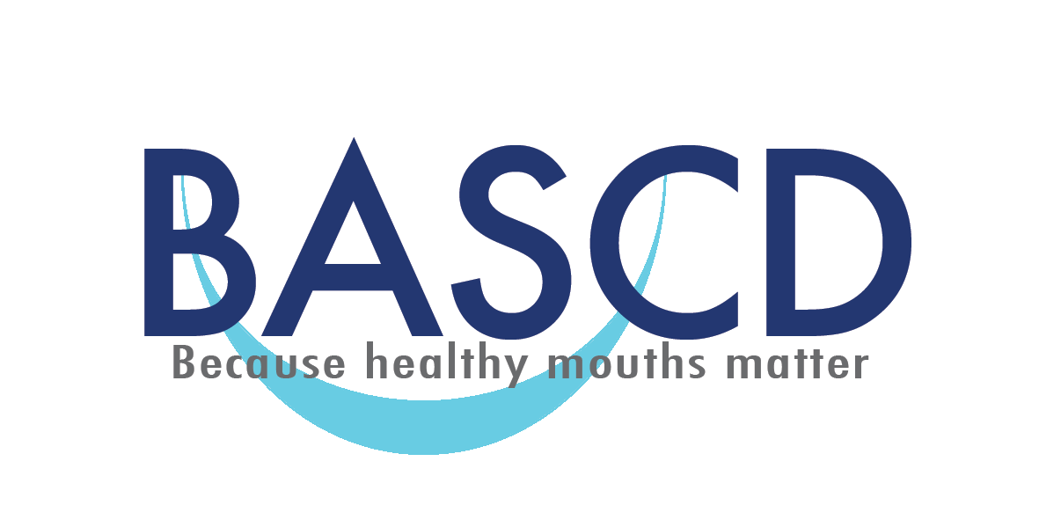

British Association for the Study of Community Dentistry (BASCD)
Keith Woods Essay Competition 2019

The British Association for the Study of Community Dentistry (BASCD) invites entries to the Keith Woods Essay Competition. This competition is open to any undergraduate dental, undergraduate dental therapy, undergraduate dental hygiene or undergraduate dental nursing student registered at a Dental School in the United Kingdom.
A prize of £200.00 and Certificate will be awarded to the winner of the competition. These will be presented at the BASCD Autumn Scientific Meeting, which will be held in November 2019.
The title for this year’s essay is:
“The challenges and opportunities for promoting oral health in a digital world”

Aims of the Competition
BASCD is the UK’s professional association for the science, philosophy and practice of promoting the oral health of populations and groups in society. The British Association for the Study of Community Dentistry was founded in 1973 by leading dental professionals concerned with the needs of populations and groups in society, with a specific emphasis on preventing and controlling oral diseases and conditions.
The essay completion is designed to foster the interest of the next generation of dental professionals in public health dentistry.
This competition is dedicated to the memory of the late Keith Woods, a distinguished former member of the Association.

Competition rules
1. The competition is open to any undergraduate dental student (including those studying dentistry already in possession of another degree), undergraduate dental therapy, undergraduate dental hygiene, or undergraduate dental nursing student registered at a dental school in the United Kingdom. 2. A typed copy of your essay should be submitted as a Microsoft WORD document via e-mail to bascd@outlook.com by the closing date, which is 5pm on 2nd September 2019. 3. Your essay should be no more than 2000 words in length (excluding references). This word limit includes abstracts, titles, and other text. The total number of tables or figures should not exceed four. 4. You may use a referencing format of your choice. 5. Your name and year or course of study (i.e. dentistry/therapy/hygiene/dental nursing) or the name of your dental school should not appear within the body of your essay. You should use a pseudonym (made-up name) and this should be inserted on the Second page and as a header throughout your essay.

6. The front page of the Essay should contain:

Your full name
The pseudonym you have chosen to use for your essay.
Your Course of Study
Your Year of Study
Your Dental School
Your postal address
Your formal university e-mail
Your telephone number
The word count of your essay (excluding the above details and references).

This front page will be removed from your essay, and the essay judged by a panel selected by BASCD. In this process you will be identified only by your pseudonym.

Any entry not compliant with the above instructions will be excluded.

7. Potential entrants are permitted to discuss their essay with staff but the submitted piece must be their own work. Information and concepts from the literature must be appropriately referenced. Plagiarism software will be used to screen the winning entry for originality.
8. The winner will be notified by 5pm on the 11th October 2019, and the name and school of the winner will appear on the BASCD website www.bascd.org.
9. The winner will receive a certificate and prize of £200.00. The prize will be presented at the BASCD Autumn Scientific Meeting, which will be held in November 2019 Cavendish Conference Centre, London. Attendance at the conference will be free for the winner and the Association will meet reasonable travel costs from within the UK, following agreement.
10. At the discretion of the President of BASCD students who have entered the competition and have been placed second or third may be given the opportunity to attend the BASCD Autumn Scientific Meeting, in November 2019, free of charge. The association cannot meet travelling costs for these students.
11. The decision of the judging panel will be final and no discussion regarding the competition outcome will be entertained and no feedback to entrants will be provided.
12. By submitting the essay, students consent for their essay to be uploaded onto the BASCD website, in circumstances where they are the winner.
13. A copy of these rules is available on the BASCD website www.bascd.org

Completed entries
Completed entries, adhering to the above rules and guidance should be sent to bascd@outlook.com by 5pm 2nd September 2019.

If you have any enquiries, please contact: Jessica Brewster on BASCD@outlook.com

